UNIT-I

- Describe the product cycle followed in a CAD/CAM system.
- Explain the software configuration of a graphics system.
- Discuss CAD/CAM hardware components
- Explain about different display devices.
- Explain 2D transformation matrix for translation, rotation and scaling with a neat diagram.
- What is the necessity of transformation? Give 3D homogeneous transformation matrix for
  - XY-Flip (ii) YZ-Flip (iii) O-Flip
- Compare traditional and the CAD/CAM based product cycle.
- Explain the basic structure of a computer
- Explain product cycle with the implementation of CAD/CAM technology
- List and explain any three input and display devices.
- Explain about raster scan graphics coordinate system
- Discuss the various display devices that are used for displaying graphic information? the merits and demerits of each one.
- Discuss the influence exerted by the computers on the manufacturing
- The unit square with vertices A (1, 1), B (2, 1), C (2, 2), and D (1, 2) is transformed in the following sequence.
    - Scaled about the origin by factors of 4 and 2 in the x- and y- directions.
    - Rotated about point B through 900. What are the coordinates of the vertices of transformed geometry?
- Explain 3D transformation matrix for translation, Rotation and Scaling with neat figures. Explain the classification of projections. Classify the memory types and storage devices used in a computer system.

UNIT-II

- List out the requirements of geometric models and explain the need of geometric modeling?
- Explain the B-spline curve with a neat figure and state the advantages.
- Discuss the different modeling techniques in CAD.
- Explain B-spline surface with a neat figure and state the advantages of this surface over Bezier surface.
- Explain various requirements for the geometry model. Also describe Euler theory in detail.
- A line segment with endpoints P1(2,4) and P2(20,5) lying in xy plane. Rotate a line about the x axis. Which surface can be generated? Find the point on the surface at u = 0.3 and φ = π/2.
- Explain parametric and non-parametric representation of the following analytical curves
i) Lines ii) Circle iii) Ellipse iv) Parabola v) Hyperbola
- Explain Bezier curve with a neat sketch. Explain its advantages and limitations
- Explain any two hidden surface removal algorithms.
- Explain about the surface representation methods and entities.

UNIT – III

- How do you define a solid model? Explain various solid modeling schemes with their Applications and limitations.
- Explain various display control commands in drafting and modeling systems.
- Define Numerical Control. Why computer aided programs are preferred for NC machine
- Explain the role of a Part Programmer in Manual Part Programming Method and Computer
- Write any Four G-Codes and M-Codes. .
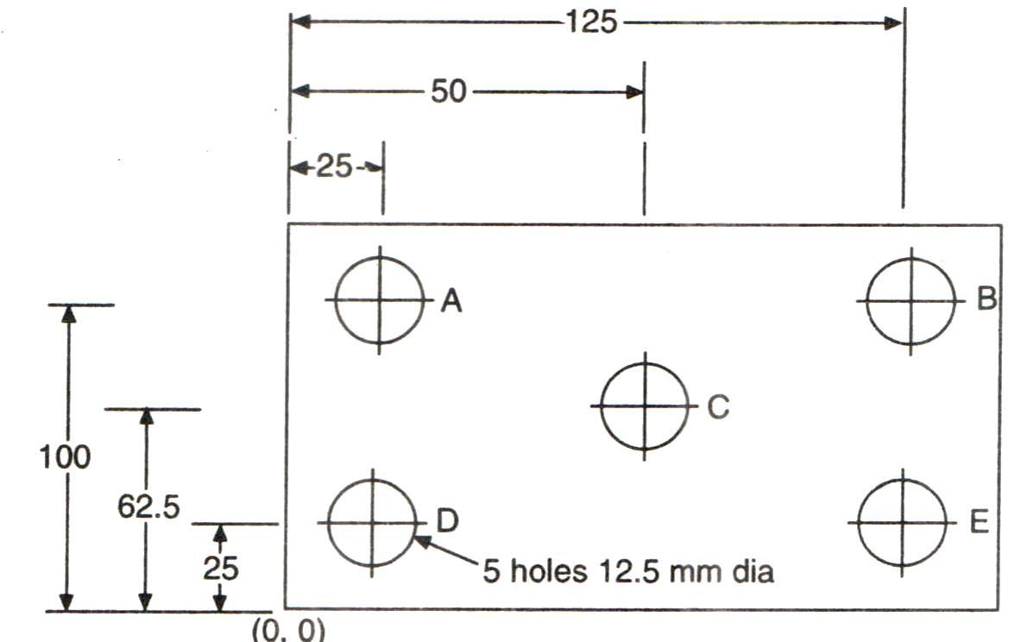
- Describe various commonly used primitives for solid modeling and explain the Boolean
operations.
- Explain various editing commands in drafting and modeling systems.

UNIT – IV

- Define Group Technology.
- List out the benefits of using Group Technology.
- Explain about coding and classification systems.
- Discuss about the Product Flow Analysis.
- Explain machine cell design in group technology.
- Define Part Families
- Discuss about the Opitz coding systems
- Explain Generative and Retrieval Process Planning
- Discuss Retrieval Process Planning
- Explain process planning & its benefits in detail.

UNIT – V

- Discuss the various methods available for the integration of Computer Aided Quality Control with CAD/CAM systems.
- Enumerate Benefits of Computer Aided Inspection.
- Explain the various activities related to computer aided quality control with a block diagram.
- Discuss the various steps involved in the inspection procedure.
- Define Inspection and Testing
- List out the objectives of computer aided quality control?
- Explain optical inspection methods in computer quality control.
- Discuss the importance of integration of CAQC with CAD/CAM.
- Explain general types of non-optical non-contact inspection methods?
- Explain the method of Part inspection using Coordinate Measuring Machine?

UNIT – VI

- List out the objectives and potential benefits of Computer Integrated Manufacturing Systems
- Explain the various control system used in CIM
- Define CIM
- What are the different basis of classifying production systems according to the quality and variety of product?
- Explain the elements of CIM in a manufacturing unit.
- Classify the types of manufacturing systems? Explain with the help of block diagrams.
- Discuss various types of data files in the CIM system.
- Explain the various material handling systems used in CIMS with a neat sketch.

